**Donatas Vasauskas**

**CS-321**

**Prof. Charles Almond**

**Lesson 5 labs**

1. **In app purchases**
2. **Banner**

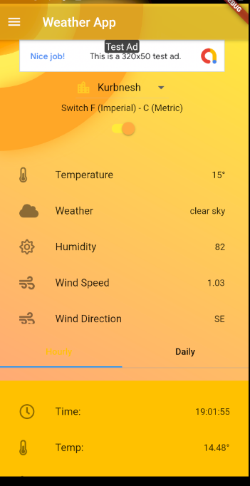

1. **AdMob**



1. **Facebook**
2. **Actions**

